13/12/2023

Chakradhar Bhogapurapu, BIBA

PYTHON DAY 2

If statement

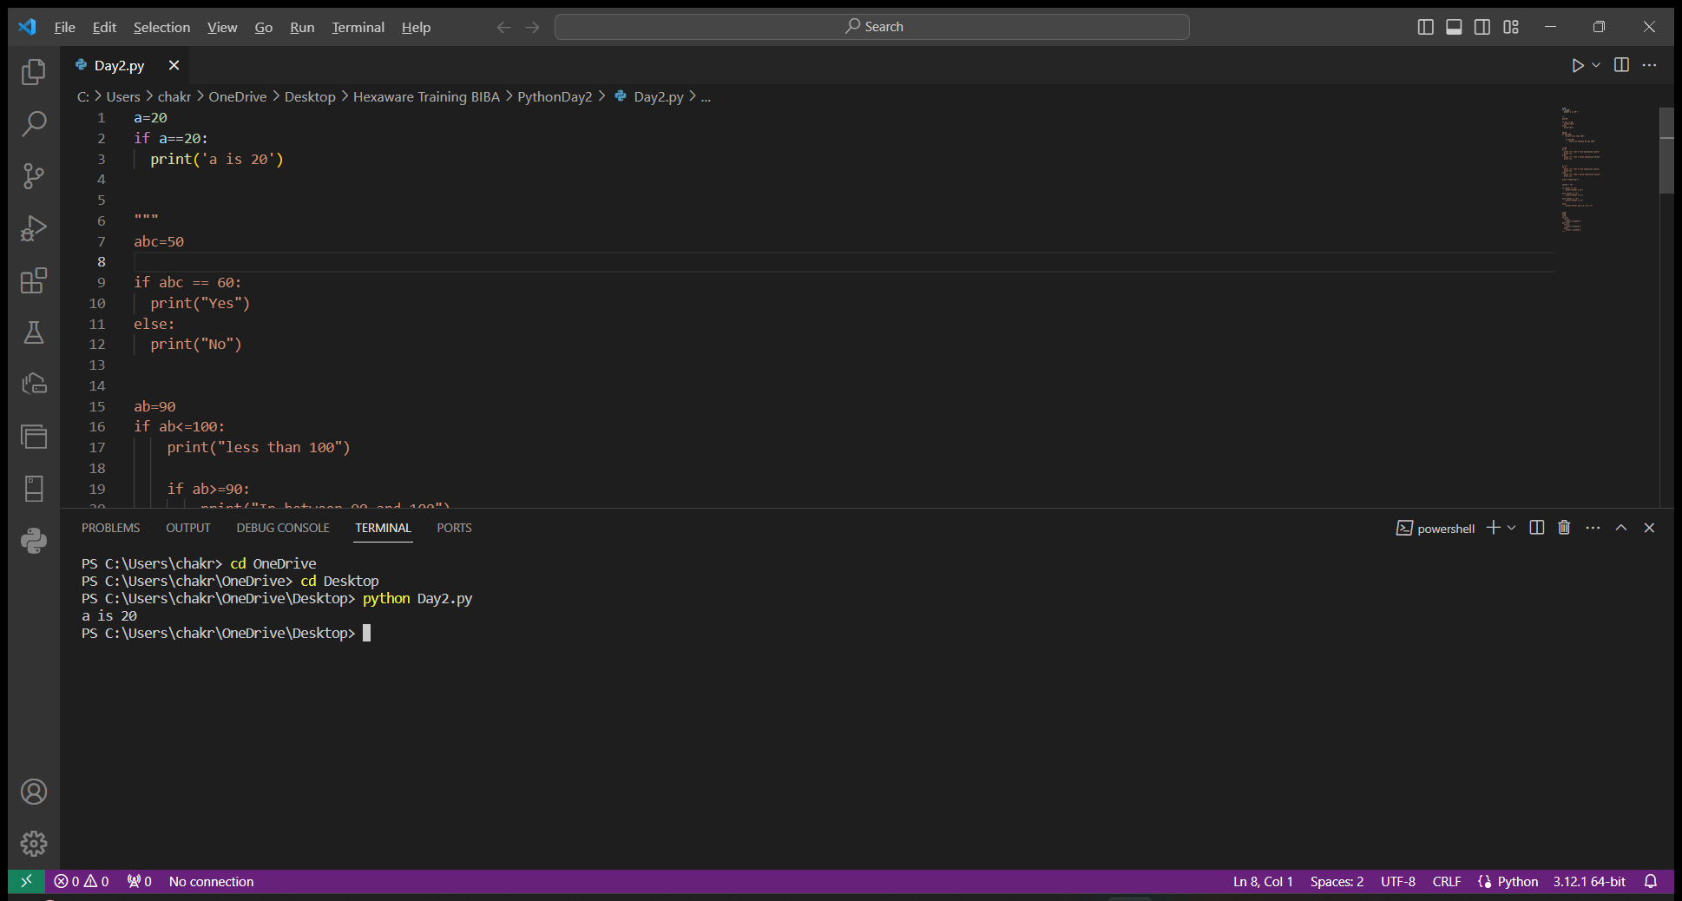

If statement is executed only if the condition is true. If condition is not true, then the if statement will not be executed.

🡪if else

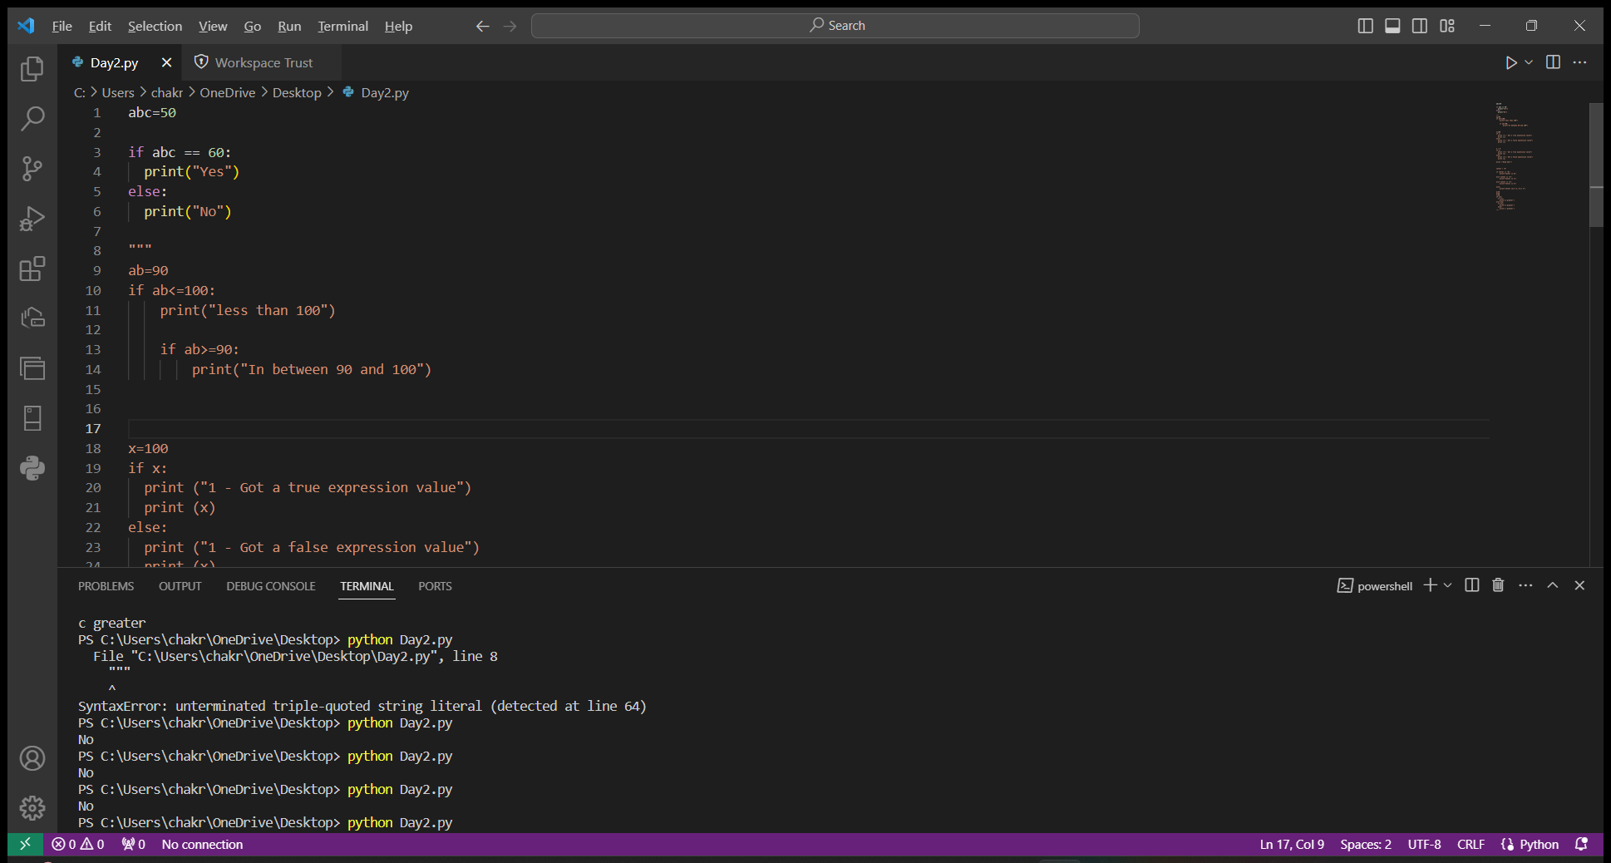

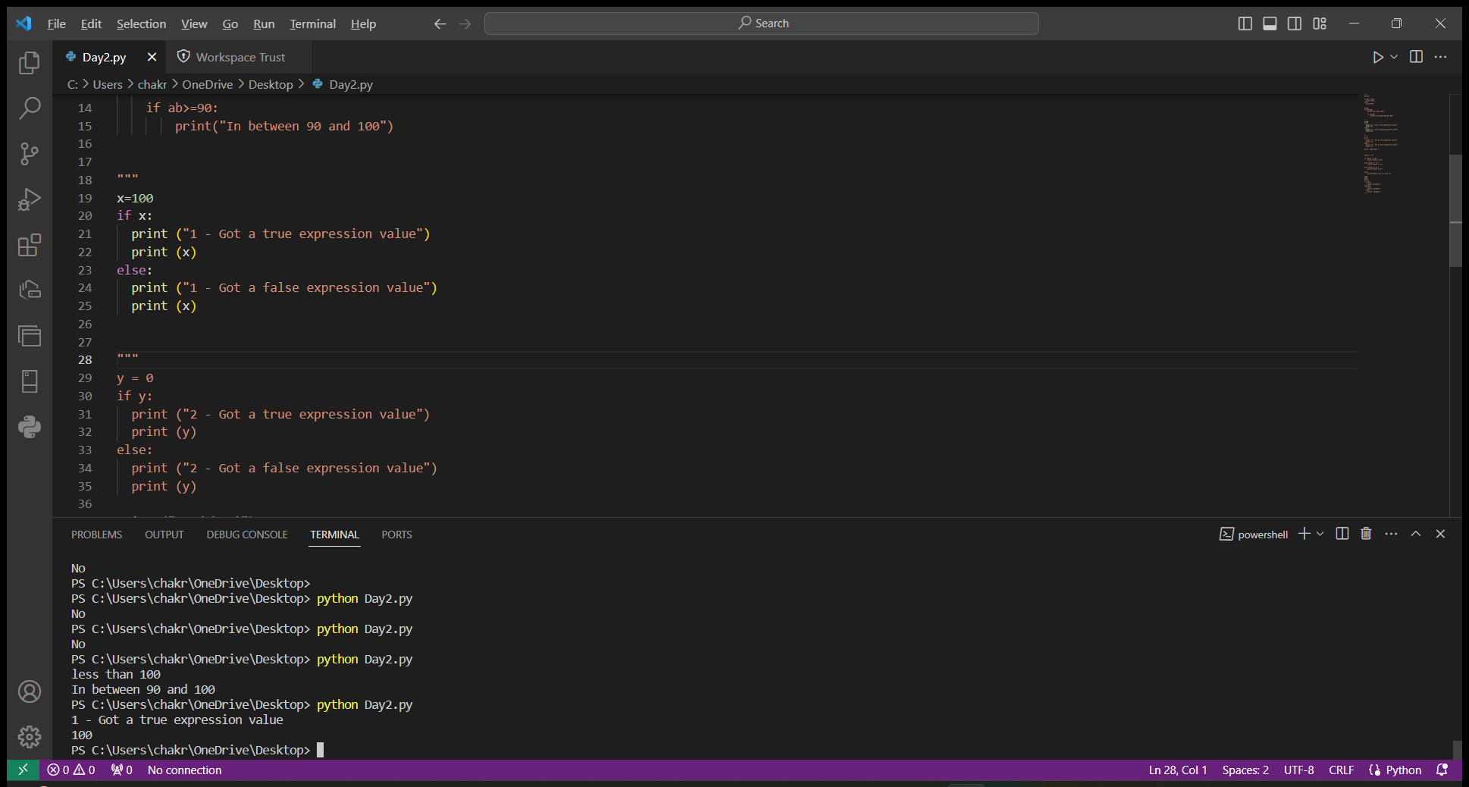

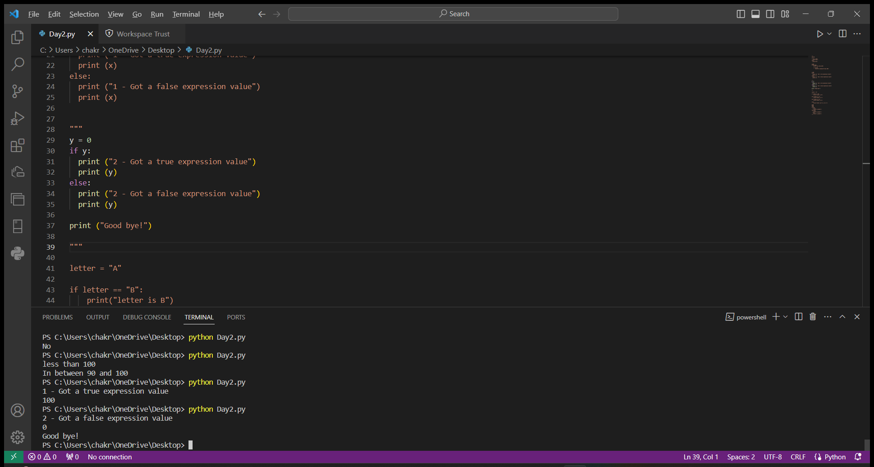

If the condition is true, then the if statement is executed. If the condition is not true, then there is else statement which will be executed.

🡪nested if

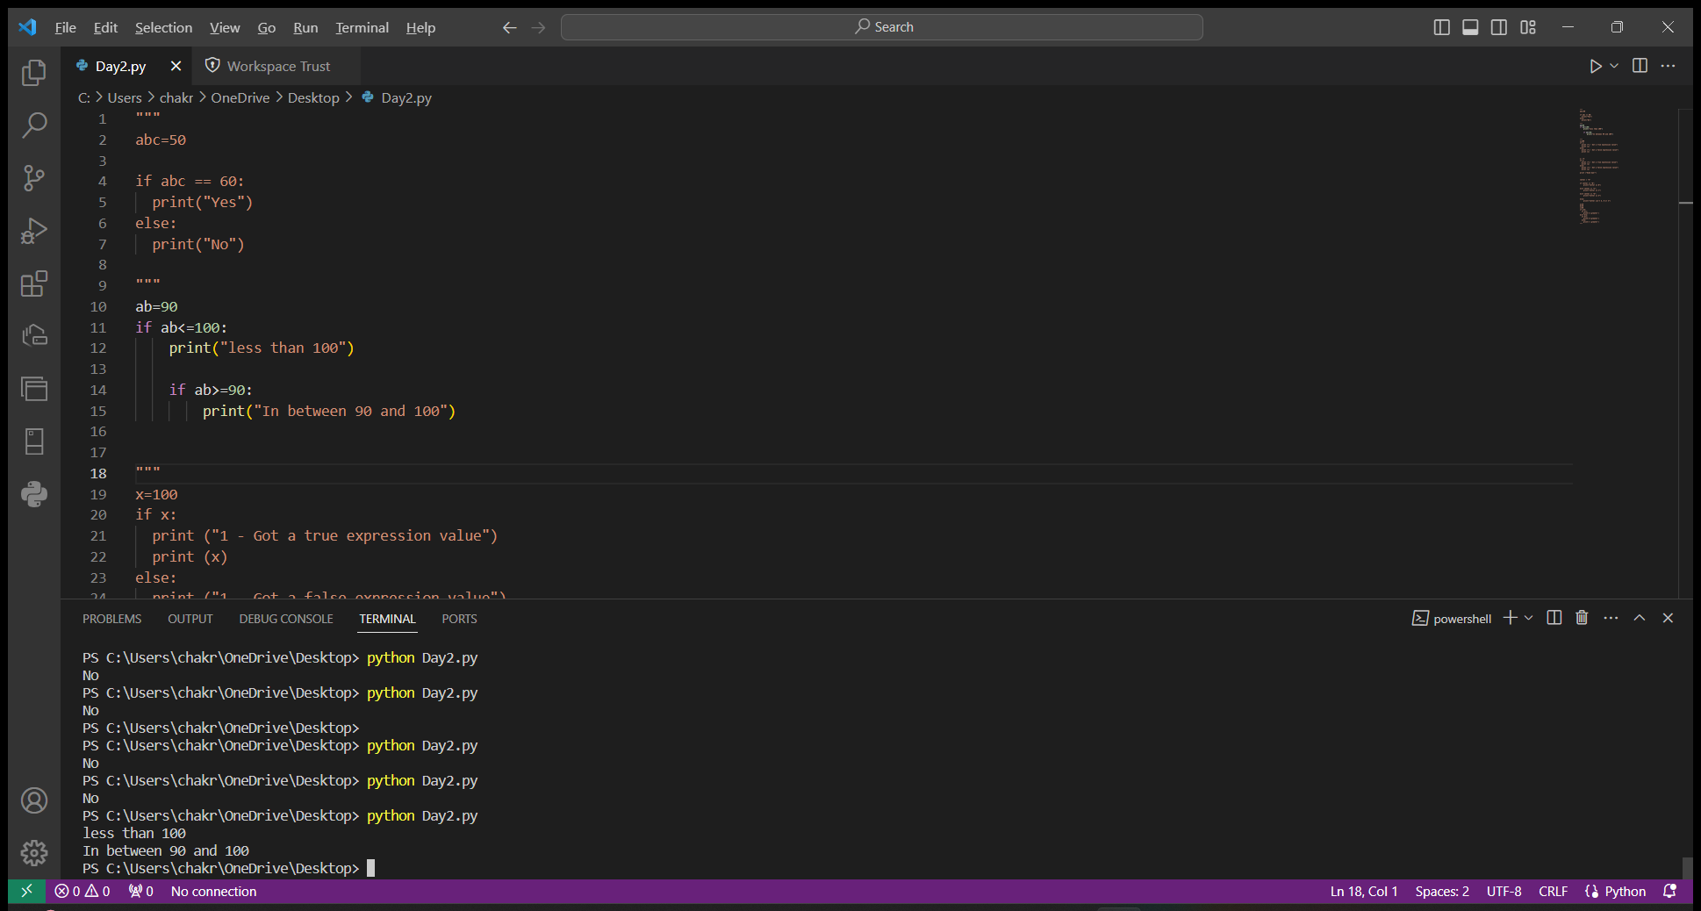

If in if condition is known as nested if. The inner if will be executed only the outer if condition is satisfied. If the inner if condition is also true, then the output will be printed.

🡪elif

if condition in else condition is elif. If the condition is not true, then the else condition is executed. Again in the else condition, there is another if and else condition. If the condition is true, then the if statement is executed. If the condition is not true, then else statement is executed.

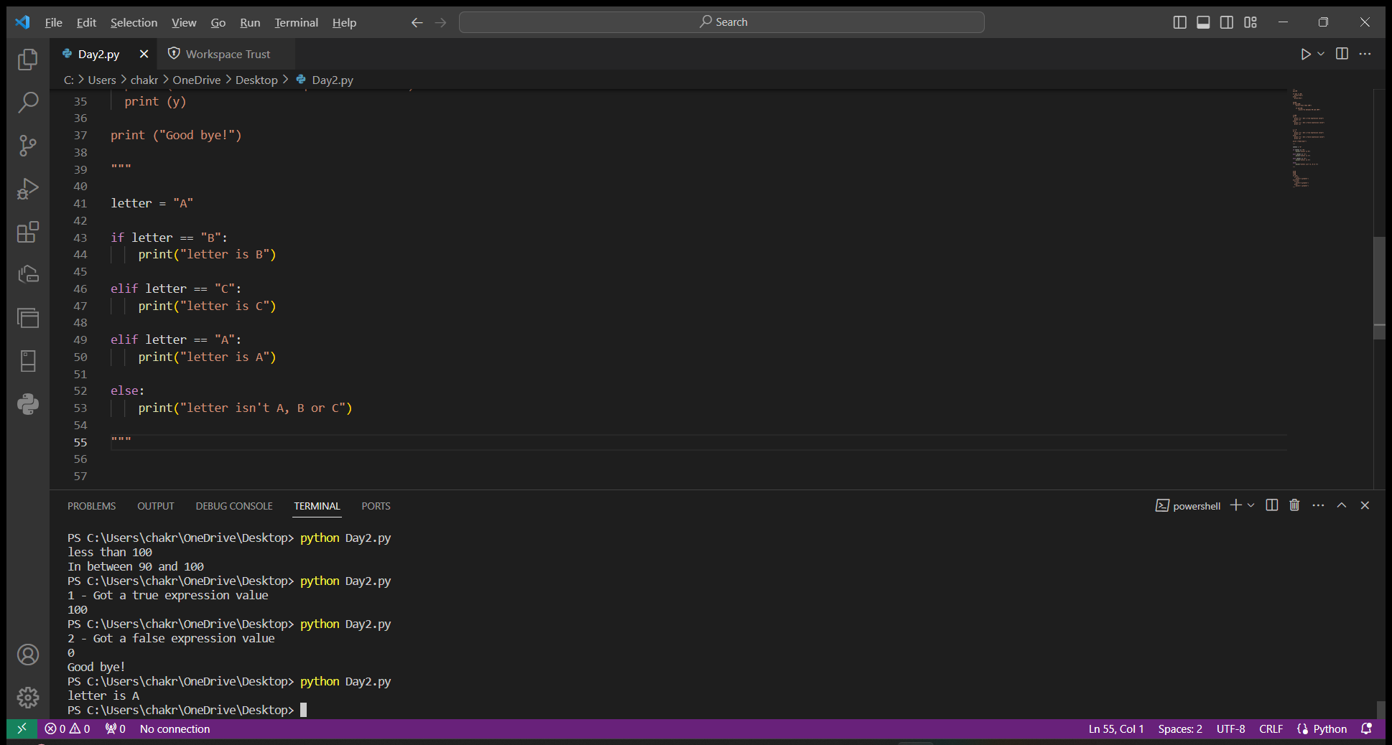

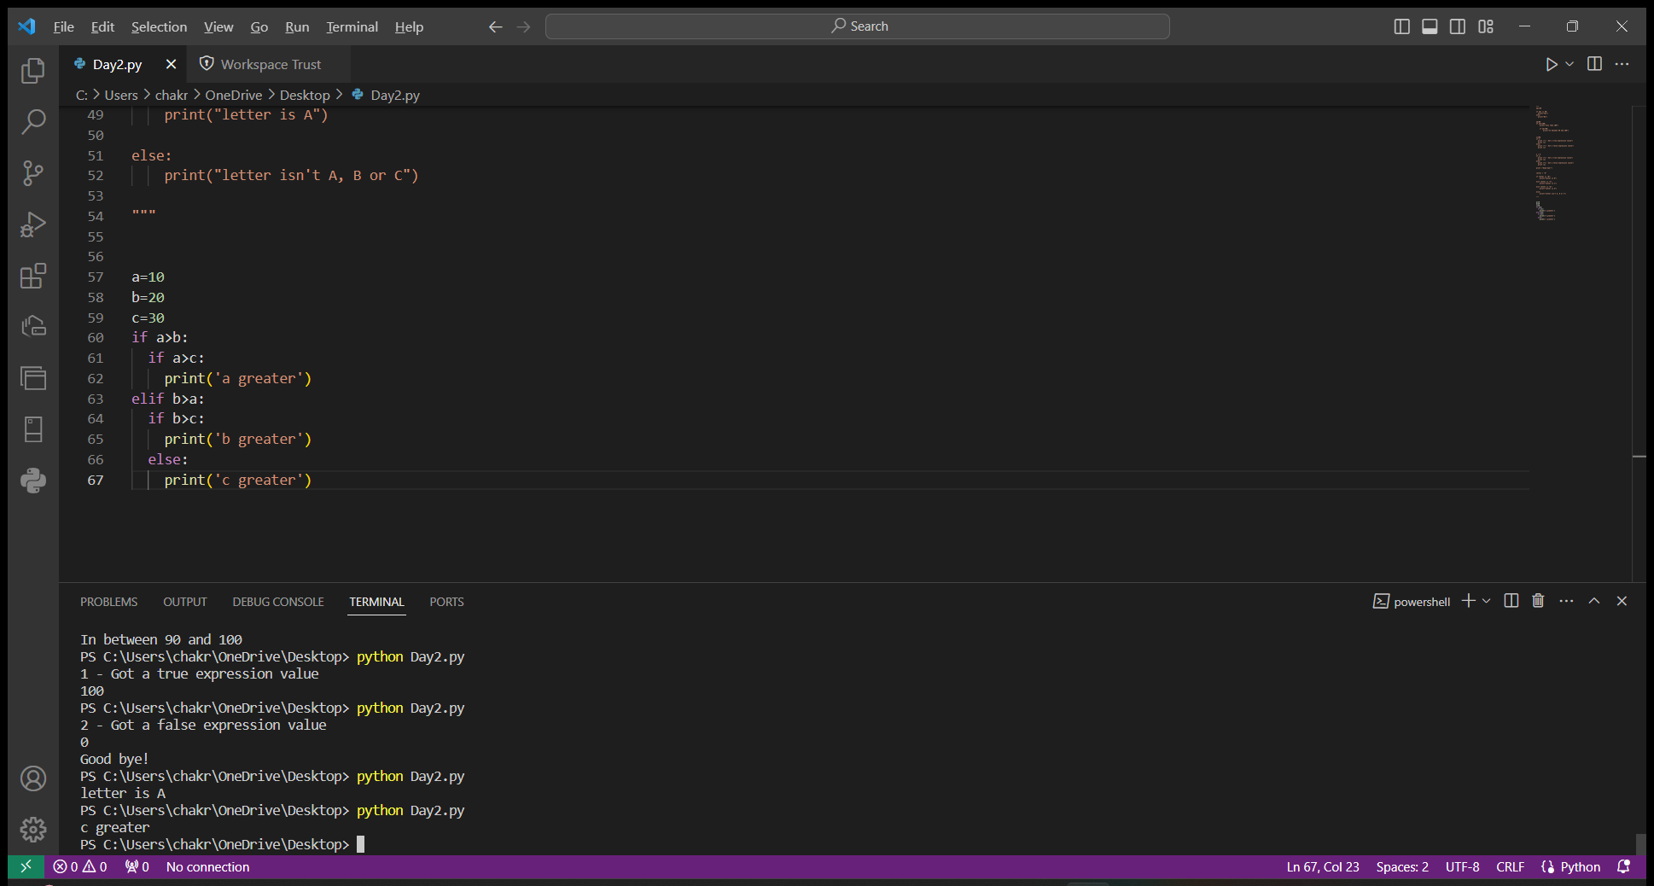

🡪while, for loop

while : while loop is used to iterate the statements until the condition is met. We use while loop only if we don’t know when the loop will end.

for : It is used to iterate over a sequence of items.. We use for loop if we know when will the loop will end.

